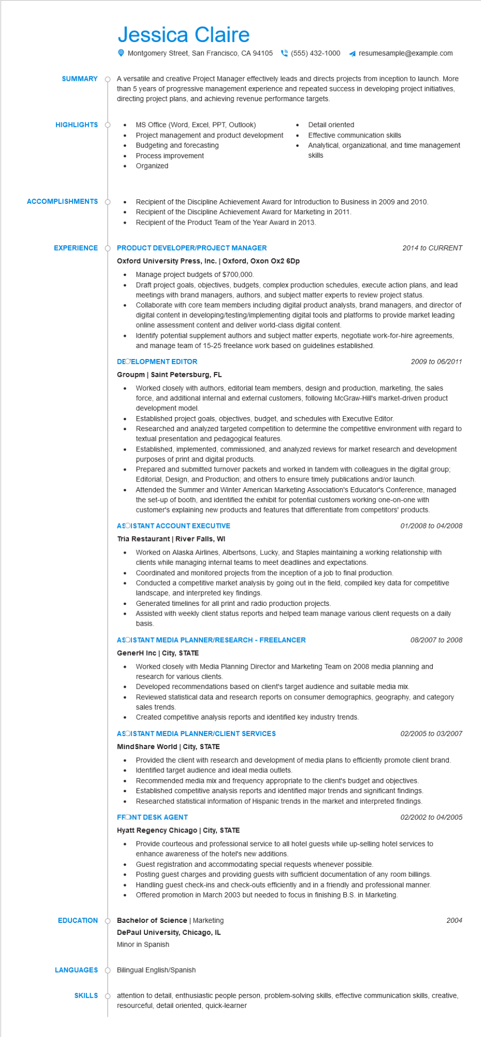
SUMMARY
Jessica Claire
Montgomery Street, San Francisco, CA 94105(555) 432-1000 ◄ resumesample@example.com
A versatile and creative Project Manager effectively leads and directs projects from inception to launch. More than 5 years of progressive management experience and repeated success in developing project initiatives, directing project plans, and achieving revenue performance targets.
HIGHLIGHTS
•
MS Office (Word, Excel, PPT, Outlook)
•
Detail oriented
Project management and product development
Effective communication skills
•
Budgeting and forecasting
Process improvement
Analytical, organizational, and time management skills
•
Organized
ACCOMPLISHMENTS
•
Recipient of the Discipline Achievement Award for Introduction to Business in 2009 and 2010. Recipient of the Discipline Achievement Award for Marketing in 2011.
· Recipient of the Product Team of the Year Award in 2013.
EXPERIENCE
PRODUCT DEVELOPER/PROJECT MANAGER
Oxford University Press, Inc. | Oxford, Oxon Ox2 6Dp
• Manage project budgets of $700,000.
2014 to CURRENT
Draft project goals, objectives, budgets, complex production schedules, execute action plans, and lead meetings with brand managers, authors, and subject matter experts to review project status.
Collaborate with core team members including digital product analysts, brand managers, and director of digital content in developing/testing/implementing digital tools and platforms to provide market leading online assessment content and deliver world-class digital content.
• Identify potential supplement authors and subject matter experts, negotiate work-for-hire agreements, and manage team of 15-25 freelance work based on guidelines established.
DEOELOPMENT EDITOR
Groupm❘ Saint Petersburg, FL
2009 to 06/2011
Worked closely with authors, editorial team members, design and production, marketing, the sales force, and additional internal and external customers, following McGraw-Hill's market-driven product development model.
Established project goals, objectives, budget, and schedules with Executive Editor.
Researched and analyzed targeted competition to determine the competitive environment with regard to textual presentation and pedagogical features.
Established, implemented, commissioned, and analyzed reviews for market research and development purposes of print and digital products.
Prepared and submitted turnover packets and worked in tandem with colleagues in the digital group; Editorial, Design, and Production; and others to ensure timely publications and/or launch.
Attended the Summer and Winter American Marketing Association's Educator's Conference, managed the set-up of booth, and identified the exhibit for potential customers working one-on-one with customer's explaining new products and features that differentiate from competitors' products.
ASOISTANT ACCOUNT EXECUTIVE
Tria Restaurant | River Falls, WI
01/2008 to 04/2008
. Worked on Alaska Airlines, Albertsons, Lucky, and Staples maintaining a working relationship with clients while managing internal teams to meet deadlines and expectations.
Coordinated and monitored projects from the inception of a job to final production.
Conducted a competitive market analysis by going out in the field, compiled key data for competitive landscape, and interpreted key findings.
Generated timelines for all print and radio production projects.
Assisted with weekly client status reports and helped team manage various client requests on a daily basis.
ASOISTANT MEDIA PLANNER/RESEARCH - FREELANCER
GenerH Inc | City, STATE
08/2007 to 2008
• Worked closely with Media Planning Director and Marketing Team on 2008 media planning and research for various clients.
• Developed recommendations based on client's target audience and suitable media mix.
Reviewed statistical data and research reports on consumer demographics, geography, and category sales trends.
Created competitive analysis reports and identified key industry trends.
ASOISTANT MEDIA PLANNER/CLIENT SERVICES
Mind Share World | City, STATE
02/2005 to 03/2007
• Provided the client with research and development of media plans to efficiently promote client brand. Identified target audience and ideal media outlets.
Recommended media mix and frequency appropriate to the client's budget and objectives.
• Established competitive analysis reports and identified major trends and significant findings. Researched statistical information of Hispanic trends in the market and interpreted findings.
FRONT DESK AGENT
Hyatt Regency Chicago | City, STATE
02/2002 to 04/2005
• Provide courteous and professional service to all hotel guests while up-selling hotel services to enhance awareness of the hotel's new additions.
Guest registration and accommodating special requests whenever possible.
• Posting guest charges and providing guests with sufficient documentation of any room billings. Handling guest check-ins and check-outs efficiently and in a friendly and professional manner. • Offered promotion in March 2003 but needed to focus in finishing B.S. in Marketing.
EDUCATION
Bachelor of Science | Marketing
DePaul University, Chicago, IL Minor in Spanish
LANGUAGES Bilingual English/Spanish
SKILLS
2004
attention to detail, enthusiastic people person, problem-solving skills, effective communication skills, creative, resourceful, detail oriented, quick-learner

